

Contract and Price List Process – Functional Requirement and Design

Projects | USME – Ascent Rental Salesforce CRM Implementation
Prepared For | USME
Document Status | Issued

Purpose and Sources
This document records how USME manages GPO and direct contracts, price lists and rebates today, and proposes how to design them in Salesforce so that manual and Excel effort goes down and hospitals are linked to GPO contracts by rule instead of by hand.
It is a discovery-stage draft: the first of several sessions over the next 2 to 3 weeks.
Item | Detail
Status | v0.1 DRAFT. As-is facts come from the call; the design is a Durvah proposal for USME to confirm.
Sources | Salesforce Contract Functionalities call, Oct 26, 2026, (USME: Sandra Melchor, Lori Rubincam, Sourabh Tiwari; Durvah: Srinivas).

1. Summary
- Contracts are not in Salesforce today. They are created and maintained in GoUSME, which syncs both ways with Salesforce. Only price books are touched in Salesforce. Rebates are calculated entirely outside any system, in Excel.
- Three things are manual and error prone: keying prices per tier and per hospital (90+ facilities on one GPO), linking each hospital to its contract, tier and GPO each time, and the monthly rebate build from about 32 Power BI reports.
- Core design idea: separate the agreement from the hospital. A GPO Agreement holds tiers and tier price books once. A GPO Membership record says which GPO, tier and rate type each hospital has. A generated Pricing Assignment then decides the price book each hospital gets. Change the membership or the agreement, and the assignments follow.
- Rebates become a calculation, not a spreadsheet: accrue per invoice line using the contract rebate %, exclude non-rebatable charge types, hold amounts for unpaid hospitals, and produce a statement per GPO per period for Finance to approve.
- Decisions needed from USME: daily versus monthly rate when a GPO allows both (Clay), which GPO wins when a hospital system is on two, who approves price changes, and whether rebate holds depend on payment status (which affects the Phase 2 payment decision; see section 7).

2. How Contracts Work Today

2.1 Contract types and structure
Item | What was described
Direct contract | Between USME and a hospital. No GPO, so no rebate is paid. Pricing agreed with the hospital and keyed into GoUSME. Sits under "USME" as the GPO partner.
GPO contract | Signed with a Group Purchasing Organization (about 20 partners listed in GoUSME, such as Vizient, Premier, HealthTrust, Novation, VGM). Has up to 4 tiers. The hospital or IDN chooses a tier and commits to it. USME pays the GPO a rebate on what it bills the hospital.
Equipment type | Each contract is for MME or BTS (two equipment lines). A hospital can have its GPO price book for MME and a direct contract for BTS, so it holds two price books at once.
Rate type | Daily rental (charged per day), or monthly rental cap (a flat monthly rate that is a discount against about 28 days; the cap days are entered). A partner takes one or the other. Some GPOs, such as Premier, let the member pick daily, monthly or both; how to handle both is not defined.
Rental only | All contracts are rentals. There are no sales contracts, although the type field offers Rental and Sales.
Expiry | Every contract has an end date. One "house pricing" contract uses a far-future date (around 2040). Contracts are 85 rows in the list Lori showed, many with 2026 to 2029 expiry.
Packages | Packages (equipment plus accessories) are part of the price list where the contract has them; not every contract does, and some are by customer.

2.2 Step by step: setting up a contract
# | Step in GoUSME | Who and notes
1 | Contract signed: direct contract with pricing written up, or GPO contract with signed pricing. Pricing is agreed outside the system between Finance and the business, or the GPO sends it. | Finance / Lori
2 | New contract: number, name, type (rental), GPO partner. Status starts as New and is set to Active when live. | Lori
3 | Rate type: daily or monthly cap (asks for cap days). Equipment type MME or BTS. Terms (Net 30, Net 60). | Lori
4 | Edit: effective date, expiration date, term in months, admin fee %, rebate fee %. | Lori
5 | View details: define tiers (up to 4, each shown with a percentage), then Export Pricing to get a sheet with Row, Delete, Model ID, Model Common Name, Tier 1 to Tier 4. Lori fills model number and price per tier and imports it. A price list for one tier can run to hundreds of models. | Lori; developers can upload
6 | Items not on the contract must bill at list price, not the contract price. Lori removes such lines from the price list so the price does not apply. | Rule from Sandra
7 | On the hospital (partner) record: add GPO member ID, GLN and HIN where they exist; in Billing and Contracts, Rental GPO, pick the GPO and assign the pricing; set the IDN (parent). | Lori, per hospital
8 | Salesforce receives the price book through the GoUSME sync. Nothing else about the contract is entered in Salesforce. | Sync

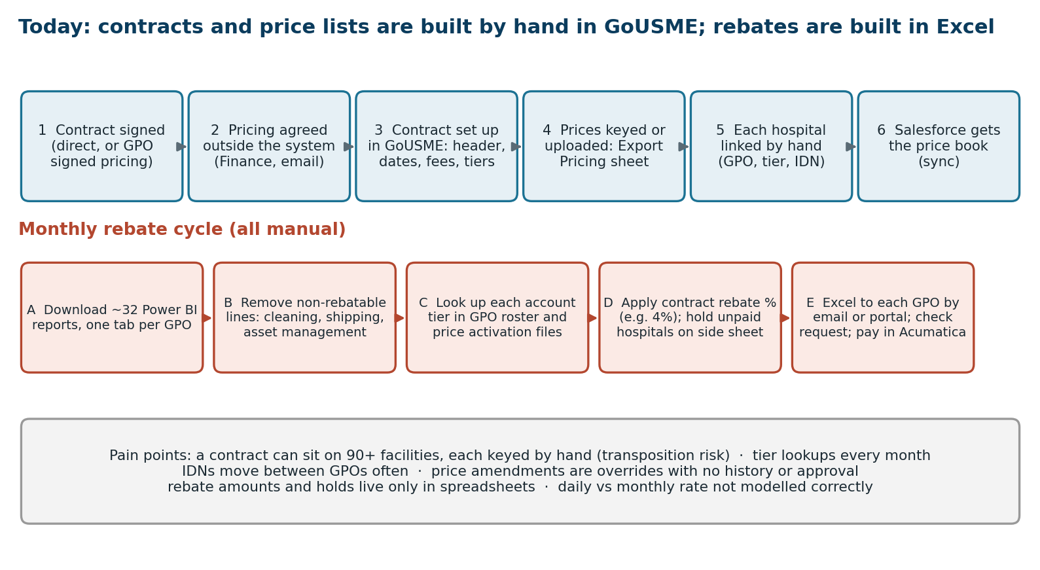
Figure 1. Current contract set-up and rebate cycle (from the call).

2.3 Accounts, IDNs, GPOs and tiers
- Hierarchy: Corporate account (parent) over IDN over individual hospitals, which USME calls "kids". Example: Penn State Health (corporate) with several hospitals. An IDN record is needed to tie the parent to the kids. Lori adds the IDN and corporate account when they are missing.
- Contracts sit at the individual hospital, not the corporate account. Hospitals under one corporate parent can have different contracts and tiers (Methodist West and Methodist South in the example).
- GPO: each IDN or hospital is linked to one GPO. A hospital system can belong to two, but USME selects one, so it is never active on both.
- Tier: tiers belong to a GPO. The tier a hospital gets is not held on the account. Lori looks it up in the GPO's price activation and roster files every month and sets it by hand. A hospital may also commit to a higher tier for an extra rebate against a volume commitment [Validate].
- Moves: IDNs leave one GPO for another often, which means re-pointing every affected hospital.

2.4 Amendments and renewals
- Price change on one item: Lori overrides the price in place. Anyone with access to the screen can do the same. There is no version, no approval and no history.
- Add or delete a line: lines are only added when an amendment to the contract is signed; Lori can delete a line.
- Renewal: if only the dates change, the same contract is extended. If pricing changes, which is most of the time, a new contract is created and every partner is updated to it by hand.

2.5 Rebates today
Step | Description
Basis | Rebate % is set per contract (4% in the example, so $71 billed gives a $2.84 rebate). It is a percentage of the invoice amount billed to the hospital. It differs by GPO.
Data | Lori downloads about 32 Power BI reports a month, one tab per GPO. Each line has partner, address, contract number and name, tier, invoice number and date, model and amount.
Cleaning | She removes lines USME does not pay rebates on: cleaning, shipping, asset management.
Frequency | Paid monthly, quarterly, twice a year or yearly depending on the GPO.
Holds | If a hospital has not paid its bills, its rebate is held, tracked on a separate sheet.
Payment | Lori sends the Excel to each GPO by email (one GPO takes an upload portal), raises a check request and a spend report. Payment is made in Acumatica. The GPO does not send an invoice.
Interfaces | Invoices go from GoUSME to Acumatica. Nothing about rebates flows out of Acumatica.

3. Main Pain Points
Pain point | Effect | Addressed by
Prices keyed per tier and per hospital | Transposition errors. 90+ facilities on one contract in one example. | 4.2, 4.4
No tier or GPO rule on the hospital | Lori looks up tier from GPO files each month; re-linking when an IDN moves. | 4.3, 4.5
Contract not linked to hospitals on creation | Developer upload or manual link for each partner after a new contract. | 4.4
Price overrides with no history | No audit, no approval, no way to see what price applied on a date. | 4.6
Items outside the contract | Risk of billing contract price on non-contract equipment; handled by removing lines. | 4.2 (fallback rule)
Rate type modelled as separate daily and monthly entries | Not how the contracts work; Premier allows both; unclear rule. | 4.2, section 6
Rebates built in Excel | 32 reports, manual cleaning, holds on side sheets, no audit trail, slow close. | 4.7
Slow GoUSME and two systems | Contracts in GoUSME, prices in Salesforce; duplicate effort and sync risk. | Section 5

4. Proposed Salesforce Design

4.1 Principles
- One agreement, many hospitals. Enter pricing once per agreement and tier, never per hospital.
- The hospital states its GPO, tier and rate type once. Everything else is derived from that.
- Versions, not overrides. A price change creates a new effective-dated version; history is kept.
- List price is the fallback. An item without a contract price bills at list price, by rule, not by deleting lines.
- Exceptions are reviewed, the rest is automatic. Staff look at what did not match, not at every line.
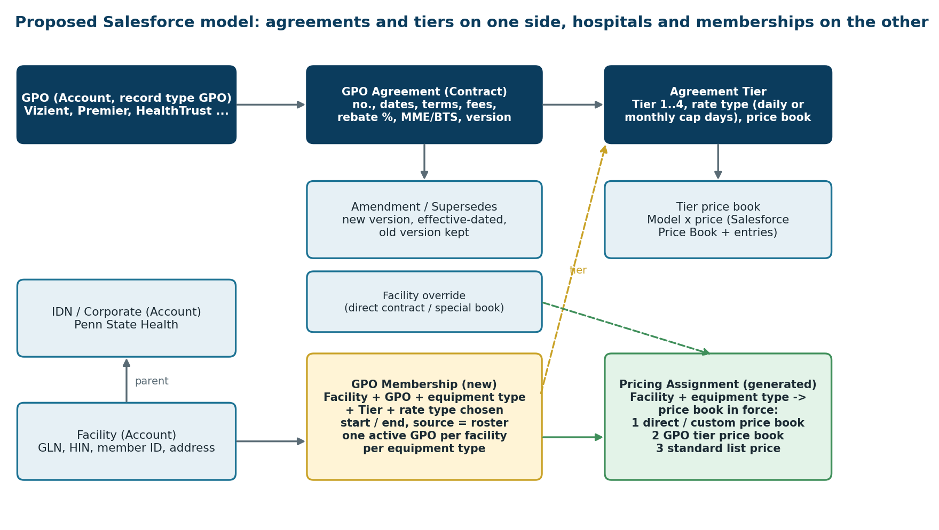
Figure 2. Proposed objects and how the price a hospital gets is resolved.

4.2 Agreements, tiers and price lists
Object | Key fields | Notes
GPO (Account, record type GPO) | Name, rebate payment frequency (monthly, quarterly, biannual, annual), payment method (email, portal), rebate-eligible charge types, contact | About 20 records today. Direct contracts use the USME account as the "GPO", with no rebate.
GPO Agreement (standard Contract, record types GPO and Direct) | Contract number, name, GPO, equipment type (MME, BTS), status (New, Active, Expired, Superseded), start, end, term, payment terms, admin fee %, rebate % , supersedes (lookup to previous version) | Native Contract gives status and dates. The extra fields are custom. A new version is created when pricing changes; dates-only change extends the same record.
Agreement Tier | Tier name, rate type (Daily or Monthly cap), cap days, discount % (shown on the GoUSME tier screen, e.g. 13.28%, 15.78%, 18.28%, 20.78% [Validate]), price book | One record per tier and rate type. Premier "daily and monthly" becomes two tier records the hospital can choose from.
Tier price book (Salesforce Price Book and Price Book Entries) | Model (product), daily price, monthly price, effective dates | One price book per agreement, tier and equipment type. Loaded by upload (Data Loader or an import screen) and checked on load. 165 price books already exist from the earlier price list work.
Package entries | Package (equipment plus accessories) priced on the same book | Only where the contract has packages.

4.3 Linking hospitals to GPOs: GPO Membership
A new GPO Membership record is the missing link today. Each row says: this facility belongs to this GPO for this equipment type, at this tier and rate type, from this date.
Field | Purpose
Facility, GPO, equipment type | Who, which GPO, MME or BTS. Facility sits under its IDN and corporate parent through the standard account hierarchy.
Tier (lookup to Agreement Tier) | The tier the hospital selected and committed to. Chosen from the tiers of that GPO.
GPO member ID, GLN, HIN | On the facility; used to match roster files.
Start, end, status, source | Active, Pending, Ended. Source: Manual, Roster load, Corporate default.
Rebate % override (optional) | For the higher-tier extra rebate case [Validate].

- Rules: one active GPO per facility per equipment type (a validation rule, so a hospital system on two GPOs must be set to one); the tier must belong to the same GPO; no overlapping dates.
- Corporate default: a membership can be created on the IDN or corporate account and pushed to its hospitals, with each hospital able to differ. Lori already enters the same tier for most hospitals under one IDN, with exceptions [Validate].

4.4 Price resolution and automatic assignment
For an order line, Salesforce and Ascent Rental find the price in this order. Use the first that has a price for the model, the equipment type and the date.
Order | Source | Example
1 | Facility override: direct contract or special price book for that facility | The customer with two contract items and the rest at Tier 1 (Lori's example)
2 | GPO tier price book from the facility's active membership | Hospital at Vizient Tier 2, BTS, daily
3 | Standard list price | Model not on the contract

- Pricing Assignment (generated). One row per facility and equipment type holds the price book in force and why. It is created and refreshed by a Flow or Apex job whenever a membership, agreement or tier changes. Staff do not edit it.
- On activating an agreement: the system finds every active membership with that GPO, tier and equipment type and shows "applies to N hospitals" for review. On approval it creates the assignments. This replaces linking each hospital by hand and the developer uploads.
- On a new version: memberships point to the tier, not the version, so the assignment moves to the new version on its effective date and the old one ends.
- IDN changes GPO: end the old membership, start the new one with its tier; assignments update from that. One change at the membership, not one per price.
- Monthly vs daily: the rate type sits on the tier the hospital chose. The order line takes the daily or monthly cap price from that tier. Where Premier allows both, see decision DR1.

4.5 Keeping memberships current: roster loads
Lori now downloads a price activation and a roster file per GPO each month and looks accounts up by name and address. Proposed: a Roster Load screen. She uploads the file, the system matches rows to facilities (member ID, GLN, HIN, then name and address) and proposes the changes: new member, tier change, member left. She approves the changes and reviews unmatched rows only. Each change creates or ends a membership. Later the file can arrive from the GPO or from Power BI without the manual download [Validate].

4.6 Managing amendments and price changes
- Price change: a Price Change Request (one or many items) with reason, effective date and approver. On approval it creates a new agreement version or tier price book version; the previous prices stay as history.
- Edit lock: price book entries on an active agreement are not directly editable except through the request. Field history tracking on agreement terms and fees.
- Alerts: expiring agreements at 90, 60 and 30 days to the contract owner; an agreement ending with no successor; a facility with no tier; an order line priced at list price on a contract hospital (warning, for review); membership and agreement tier mismatch.
- Visibility: a facility page showing GPO, tier, price book in force, and expiry; a GPO page showing the agreements, tiers, hospital count and rebate %.

4.7 Rebate management
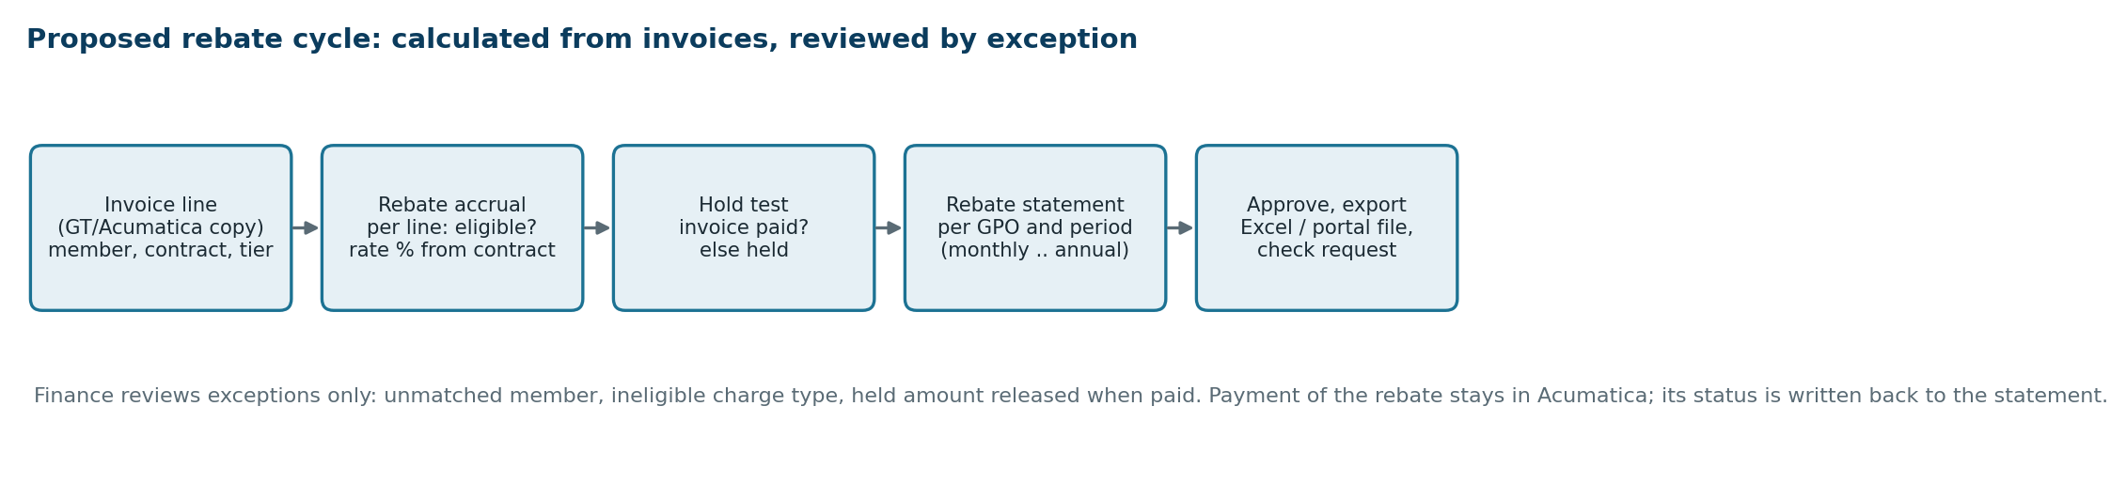
Figure 3. Proposed rebate cycle.
Object or step | Description
Rebate Accrual | One row per invoice line for a hospital with an active membership: invoice, GPO, agreement, tier, billed amount, eligible flag, rebate %, rebate amount, status (Accrued, Held, Released, Paid). Created from the invoice copy in Salesforce (see the GT to Acumatica FRS, decision D8) or from GT or Acumatica data.
Eligibility rule | Eligible by charge type: rental yes; cleaning, shipping, asset management no. A table of charge types per GPO that Finance maintains.
Hold rule | If the hospital invoice is not paid, the accrual is Held and released when paid. Needs payment status (see section 7).
Rebate Statement | Per GPO and period, following the GPO's frequency. Totals, lines, held items. Finance reviews exceptions, approves, and exports an Excel or CSV in the GPO's format, or an upload file.
Payment | Check request and payment stay in Acumatica for now. The statement records the payment reference and date, entered or fed back later.
Reports | Rebate liability by GPO, held rebates, paid rebates, spend by tier. This replaces the 32 Power BI tabs.

5. Where This Lives: GoUSME and Salesforce
Today GoUSME is where contracts are entered and Salesforce only receives the price book. The design above puts the agreement, tier, membership and rebate in Salesforce, which only works if Salesforce is the system of record for contracts. Please confirm that GoUSME is the legacy system being replaced by Ascent Rental on Salesforce, and that contract data is migrated rather than synced both ways [Validate]. If GoUSME stays for any period, a one-way load from GoUSME into the new objects is the transition.

6. Requirements
ID | Requirement | Pri | Acceptance criteria
CTR-01 | Maintain GPOs, with rebate payment frequency, method and rebate-eligible charge types. | M | GPO list of about 20 loaded
CTR-02 | Create a GPO or direct agreement with number, name, type, equipment type, dates, terms, admin fee, rebate %, and status New, Active, Expired, Superseded. | M | Matches GoUSME fields
CTR-03 | Define up to 4 tiers per agreement, each with rate type daily or monthly cap and cap days. | M | Tier records per agreement
CTR-04 | Load tier prices from a template and validate: duplicate models, missing prices, bad model IDs. Report errors by row. | M | Upload rejects bad rows with reasons
CTR-05 | Items not on the agreement price at standard list price. No manual removal of lines. | M | Test order with off-contract item
CTR-06 | Hold GPO membership per facility, equipment type and GPO with tier, rate type, dates and source. | M | Replaces manual tier lookup
CTR-07 | Block a second active GPO membership for the same facility and equipment type, and a tier from a different GPO. | M | Validation rules
CTR-08 | Generate and refresh a Pricing Assignment per facility and equipment type when a membership, tier or agreement changes. Show the source: override, tier, list. | M | Assignment changes with no manual step
CTR-09 | On agreement activation, show the hospitals it will apply to and apply on approval. | M | N shown matches membership count
CTR-10 | Support a facility override price book (direct contract, special book) ahead of the GPO tier. | M | Two-price-book hospital test (MME GPO, BTS direct)
CTR-11 | A price change is a request with approver and effective date; creates a new version; history kept; no direct overrides on active agreements. | M | Audit shows who, when, old and new price
CTR-12 | Renewal: extend dates on the same agreement when pricing is unchanged; create a successor version otherwise, and move assignments on the effective date. | M | Renewal test
CTR-13 | Roster Load: upload a GPO file, match to facilities, propose membership changes, approve, show unmatched rows. | S | Match rate reported
CTR-14 | Alerts for expiry (90, 60, 30 days), no successor, facility without tier, list-price line on a contract hospital. | S | Alert tests
CTR-15 | Accrue rebate per invoice line using the agreement rebate %, with eligibility by charge type. | M | Sample month agrees to Lori's Excel
CTR-16 | Hold accruals for unpaid hospital invoices and release when paid. | S | Depends on payment status
CTR-17 | Produce a rebate statement per GPO and period, with approval and export in each GPO's format. | M | One GPO piloted
CTR-18 | Record rebate payment reference and date against the statement. | S | Manual entry first
CTR-19 | Reports: contracts by GPO, tier and expiry; hospitals per tier; rebate liability, held and paid. | S | Replace Power BI tabs
CTR-20 | Migrate existing contracts, tiers, price lists and hospital links from GoUSME, with reconciliation counts. | M | Counts match

7. Decisions and Open Questions
ID | Topic | Question or recommendation | Owner
DR1 | Daily and monthly together | When a GPO (Premier) allows both, can a hospital have both? Recommend: one rate type per membership per equipment type for go-live, with a second membership if both are needed; later a rule such as monthly cap applies from 28 days. Clay wants this defined. | Clay / USME exec
DR2 | Two GPOs | Confirm USME always picks one GPO per hospital and equipment type, as stated. The validation in CTR-07 enforces it. | Lori / Sandra
DR3 | Who approves price changes | Name approvers by contract type and value. | USME Finance
DR4 | Source of truth | Confirm Salesforce replaces GoUSME for contracts (section 5). | Sourabh
DR5 | Rebate holds and payment status | Holds need to know if the hospital paid. The Oct 27 integration call put payment status in Salesforce in Phase 2. Either bring a minimum paid/unpaid feed forward for rebates, or keep the hold as a manual flag on the accrual until Phase 2. | Sourabh / Durvah
DR6 | Rebate % by tier | Is the rebate % one value per agreement or different by tier and commitment (higher tier gives an extra rebate)? | Lori
DR7 | Corporate default | Can a membership at the IDN or corporate account apply to all its hospitals by default? | Lori
DR8 | Amendments | How often do mid-term price changes happen, and do they apply to existing orders or from the effective date forward? | Lori
DR9 | Rebate eligible charges | Full list of non-rebatable charge types per GPO. | Lori
DR10 | Rebate by GPO file formats | Collect each GPO's format and the one with the portal. | Lori

8. Approach and Next Steps
Phase | Content
1. Foundation | GPO, agreement, tier and price book objects; membership; pricing assignment; price upload; migration from GoUSME. Largest effort reduction: no per-hospital keying.
2. Maintain | Price change requests and versions, renewals, alerts, roster loads.
3. Rebates | Accrual, eligibility and hold rules, statements and exports for the GPOs, starting with one or two.

- Lori: the GPO-to-hospital hierarchy diagram, due Wed Oct 28; Srinivas reviews before the next session is scheduled.
- Sourabh: share the call recording and transcript on SharePoint.
- Durvah and USME: document and simplify the pricing and tier business rules (daily versus monthly, dual GPO) to present to Clay with the proposed solution.
- Next session asks: one GPO as a worked example end to end (agreement, tiers, price list, five hospitals, one month of rebate), the monthly rebate Excel, and a sample roster file.

